Brad Beachell Student Studio

Design Document for:

Deputy FluffButt

One Liner, i.e. “Not all heroes are big”

Written by Brad Beachell

Version # 1.30

Table of Contents

Number each section and include the beginning page number

Design history 1
Game overview 1
Story 1
Feature set 2-5
User interface 6
Arts and video 7-12
Music and sound 13

Design History
This is a brief explanation of the history of this document. In this paragraph describe to the reader what you are trying to achieve with the design history. It is possible that they don’t know what this is for and you need to explain it to them.

Version 1.10

Version 1.10 includes some tuning and tweaking that I did after making my initial pass at the design. Here is what I changed.

- I added a design for the characters if they were quadrupeds.
- Demoted FluffButt to a deputy, it sounded better.
Version 1.20
- Added color pallet references
- Added to ui the platform ui
- Added to ui the cactus and rock ui.
- Added gui draft
- Changed color to my text
Version 1.30
- Added the rabbit sprite
- Created animation loop
- Added placeholder skybox, will be replaced once we have a better idea of what style we want the sky to be like.

Game Overview
This could be actually taken from your One Pager document. Keep the information light and informative. One or two paragraphs are sufficient. Questions that you might answer in those paragraphs:

You must collect the stars Bandit Coyote stole from FluffButt’s bank.
It is an endless side scroller.
It is single player.
You have Deputy FluffButt and Bandit Coyote.

Story (if there is one)
Write the synopsis of the story told by the game. Include the back-story and detailed character descriptions if it helps. Indicate the game text and dialogue requirements so they can be added to the schedule. Some game designs focus so much on this, that they overlook everything else that should be in the spec. Telling a story is not the focus of most games. Of course, if you are doing an adventure game, it is extremely important. Expand and organize this section as is necessary to tell the story events.

Bandit Coyote has stolen all the stars from the bank. The people of Fur Gulch have deputized FluffButt to go after the thief.
FluffButt is a farmer but prides himself on how high he can jump and does have quite a punch.

Bandit Coyote, is a bandit that stole stars from the bank.

Feature Set
The game features describe the game play in detailed terms, starting with the vision of the core game play, followed by the game flow, which traces the player activity in a typical game. The rest is all the infinite details.

Core Game Play
In a few paragraphs describe the essence of the game. These few words are the seeds from which the design should grow. Planted in the fertile soil of a known market, they should establish roots that anchor the vision firmly in place and help ensure a successful game. This is similar to the description section in the game concept, except that it’s non-narrative and usually expressed clearest in bullet points, though this could vary depending on the type of game.

The player jumps in chase of stolen stars that randomly drop on to the ground. You must avoid pitfalls and random attacks from the bandit himself. Who will steal the stars from you.

Game Flow
Trace the typical flow of game play with a detailed description of player activity, paying close attention to the progression of challenge and entertainment. If the core game play is the root of a tree, the game flow is the trunk and the branches. All activity should actualize and extend from the core game play. Be specific about what the player does, though try to use terms like "shoot", "command", "select" and "move" rather than "click", "press" and "drag". This keeps the description distinct from how the actual GUI will work, which is likely to change. Refer readers to specific pages in the User Interface section when you first mention a GUI element such as a screen or window or command bar.

The game will be an endless runner/platformer to see how many stars they can collect. The game will end if you fall into a pitfall or the bandit has taken your HP to 0.

Characters
These are the actors in the game controlled by the players or the AI. This should include a brief description and any applicable statistics. Statistics should be on a rating scale i.e. A to Z or Low to High, so that it’s clear where units stand in relation to each other in broad terms. It’s a waste of time plugging in the actual numbers until the programmers have written the technical specification and created an environment for you to experiment with the numbers. Special talents or abilities beyond the statistics should be listed and briefly described, but if they are complex, they should be expanded upon in the game play Elements section.

Player, Deputy Fluffbutt, a humble farmer sent out to collect the stars. He has a higher jump, even a double jump.

Enemy, Bandit Coyote, he is faster than Fluffbutt, but can only jump once.

Game Play Elements
This is a functional description of all elements that the player (or characters/units) can engage, acquire or otherwise interactive with. These are such things as weapons, buildings, switches, elevators, traps, items, spells, power-ups, and special talents. Write a paragraph at the start of each category describing how these elements are introduced and interacted with.

Stars, these act as your points.
Water, this restores your health.
Cactus, this is a barrier that also when destroyed can contain stars and water.

Game Physics and Statistics
Break out how the physics of the game should function, i.e. movement, collision, combat etc., separating each into subsections. Describe the look and feel and how they might vary based on statistics assignable to the characters, units and game play elements. Indicate the statistics required to make them work. Get feedback from the programmers as you write this, as how the game handles the physics and the quantity of the statistics will severely impact performance issues.

This can get a little dry, but avoid getting too technical. Avoid using actual numbers or programming terms. These will come later in the technical specification, written by the programmers who will want to do things their way (usually the right way). Just tell them what you want to accomplish. For example: "The units should slow down when going up hill and speed up when going down, unless they are a hover or flying vehicle. How much they are affected should be a factor of their climbing and acceleration statistic as well as the angle of the incline." You would not tell the programmers what math to use to adjust the speed. Assuming you are not a programmer yourself, they’re just better at that than you.

FluffButt, will need to jump higher and have a second jump. Strech goal will be to have an attack
Bandit Coyote, we want him to be able to attack and steal the stars from FluffButt.

Artificial Intelligence
Describe the desired behaviour and accessibility of the AI in the game. This includes movement (path finding), reactions and triggers, target selection and other combat decisions such as range and positioning, and interaction with game play elements. Describe the avenue through which the AI should be controlled by the level designers, i.e. using .INI files, #include files of game stats or C-code, proprietary AI scripts, etc.

Bandit Coyote, will randomly attack.

Platforms will spawn randomly. This will be done by it pulling randomly from a list.

Cactus and stones should randomly generate to create new terrain with the prefabs. I am still working on this to get the cactus to stick to the terrain using a similar script as the platforms. Currently is not working.

User Interface
The interface changes so very often that it almost seems pointless to document it; however, it’s got to start somewhere. It’s structured here to minimize the impact of changes. It’s starts with a flowchart of the screen and window navigation, and then breaks down the functional requirements of all the screens and windows. That done, the GUI artist is free to do what he or she feels is right as long as it meets the requirements. To get him or her started you should provide mock-ups. This often is to the designer’s benefit to think everything through. Then follow up with a description of all the GUI objects that need to be programmed to make all the screens work.

Flowchart
This charts the navigation through the various screens and windows. Use VISIO or similar flowcharting tool to connect labelled and numbered boxes together, representing screens, windows, menus, etc. On the corner of each sheet, put a numbered list of all the items for easy referencing and ease of defining tasks for the programmers.
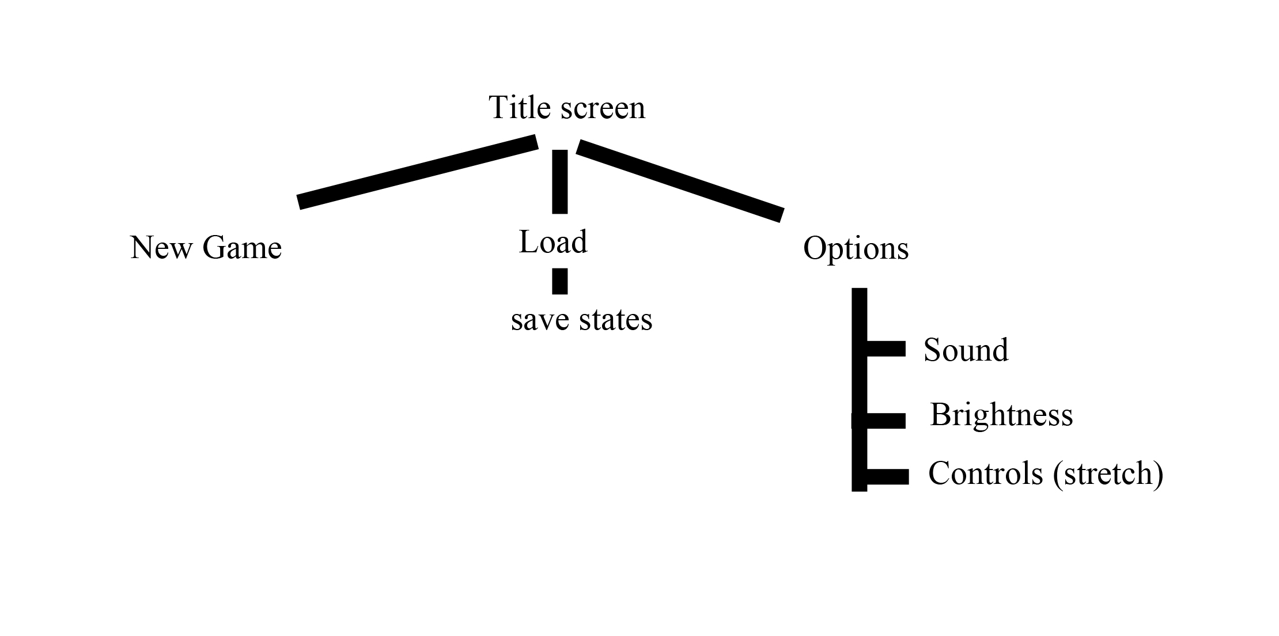

Art and Video
This should be the definitive list for all the art and video in the game. We all know how things creep up, though, so add a couple of placeholder references for art to be named later, like mission specific art and art for marketing materials, demos, web pages, manual and packaging.

Overall Goals
This is where you should spell out the motifs, characteristics, style, mood, colors etc. that make up the goals for the art. Gather consensus with the lead artists and art director and make sure they see eye to eye with the project’s director or producer. Doing so now will save a lot of time later if they end up redoing everything because the goals were never clearly defined.

We want the player to have a western feeling, using saturated colors. See below.

Color refs

Natural pallets for our feel
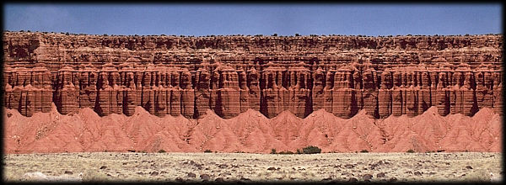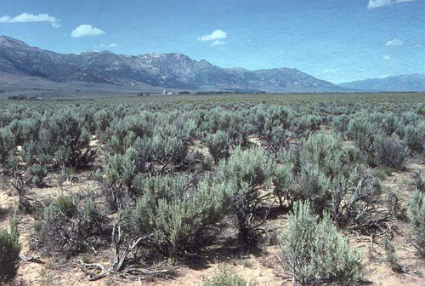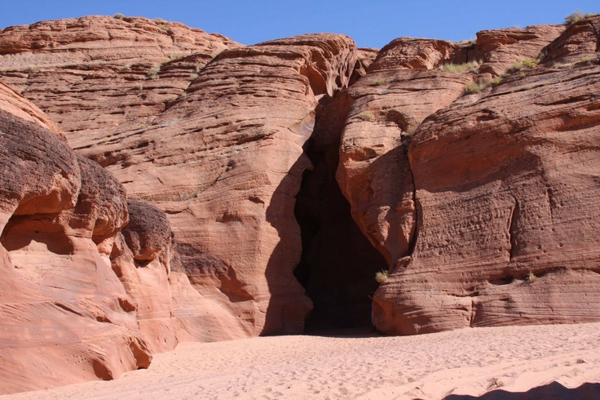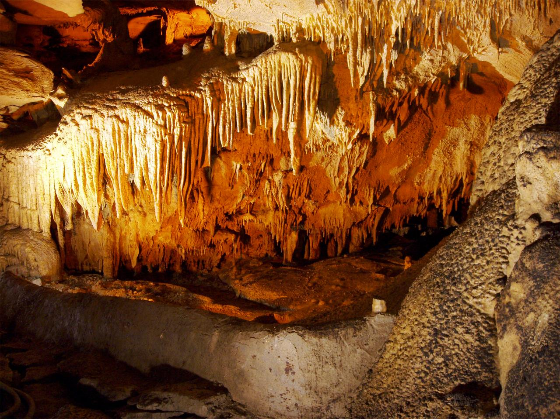

GUI
During play
Health, points/stars, pause.

A quick draft
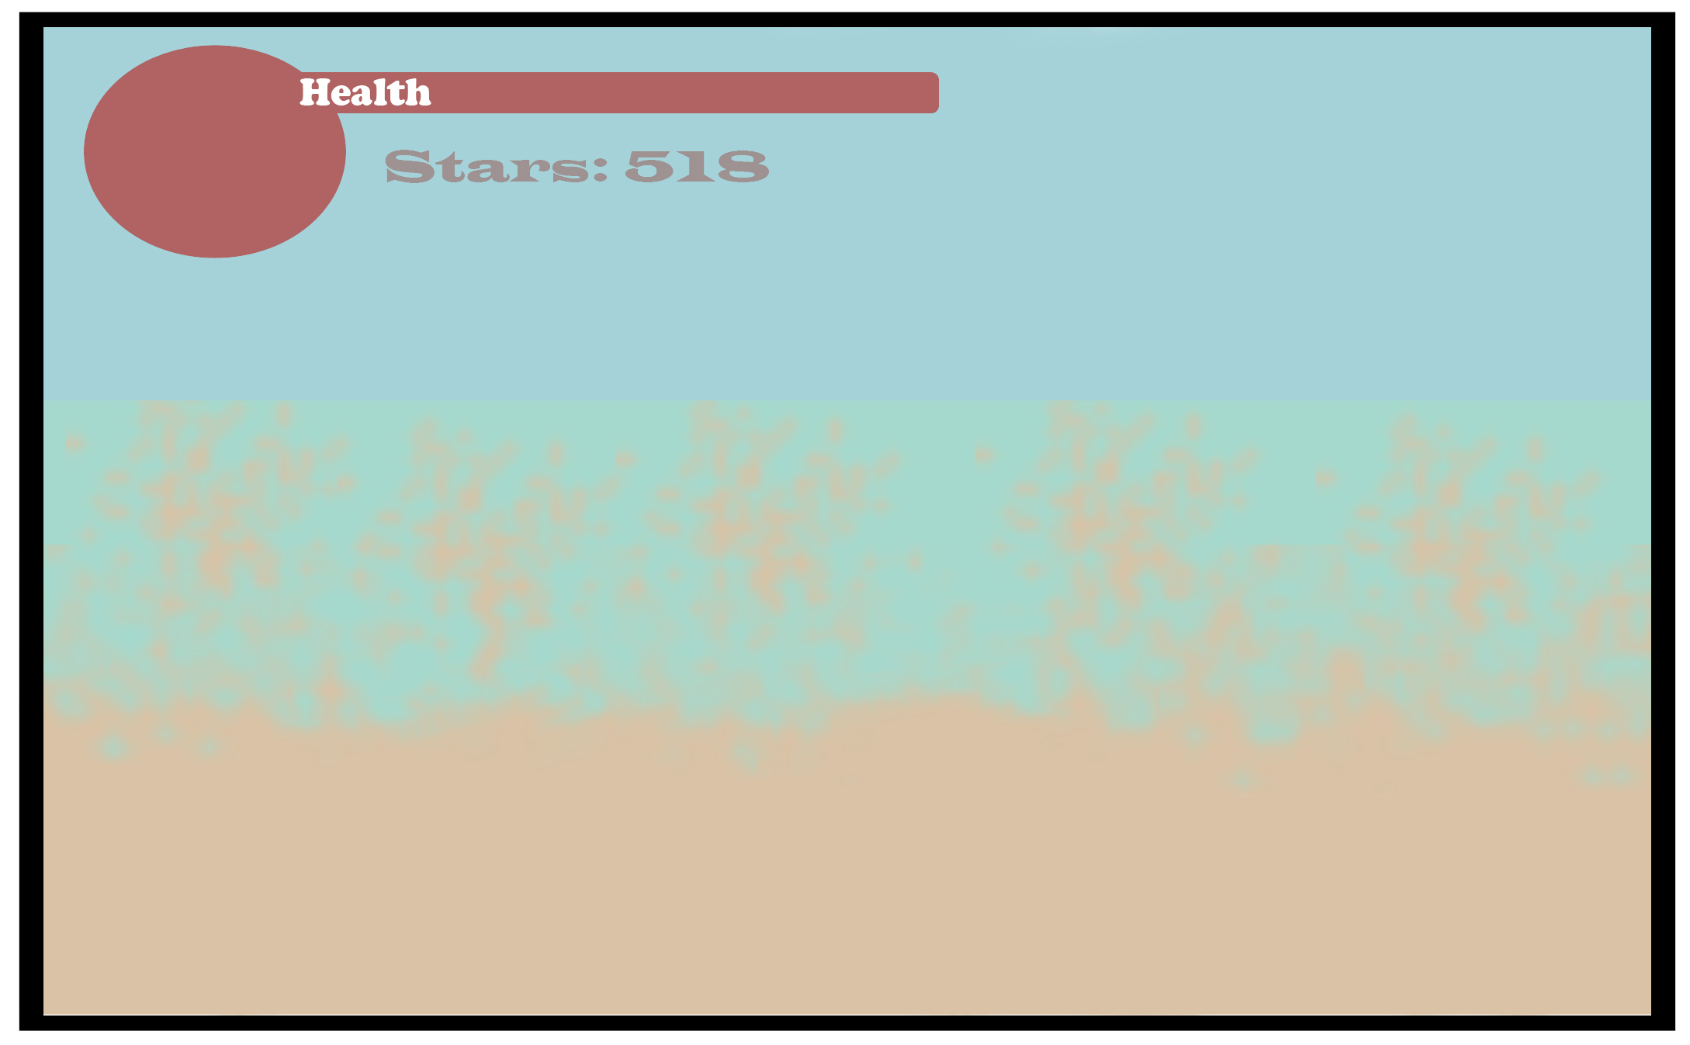

Level Creation
The level is procedurally generated, so it will be different each play. Will use the terrain templates below, painted to look like deserts.

Terrain description.

- Would be like a gulch
- Would be like a dune
- Was going to be a crevasse, but opted not to use it
- Would be a ditch
- This would be like a hanging ledge. Will not be used.
- Originally designed to be like a rock jutting out of the ground
- Like F was originally designed to be a rock.
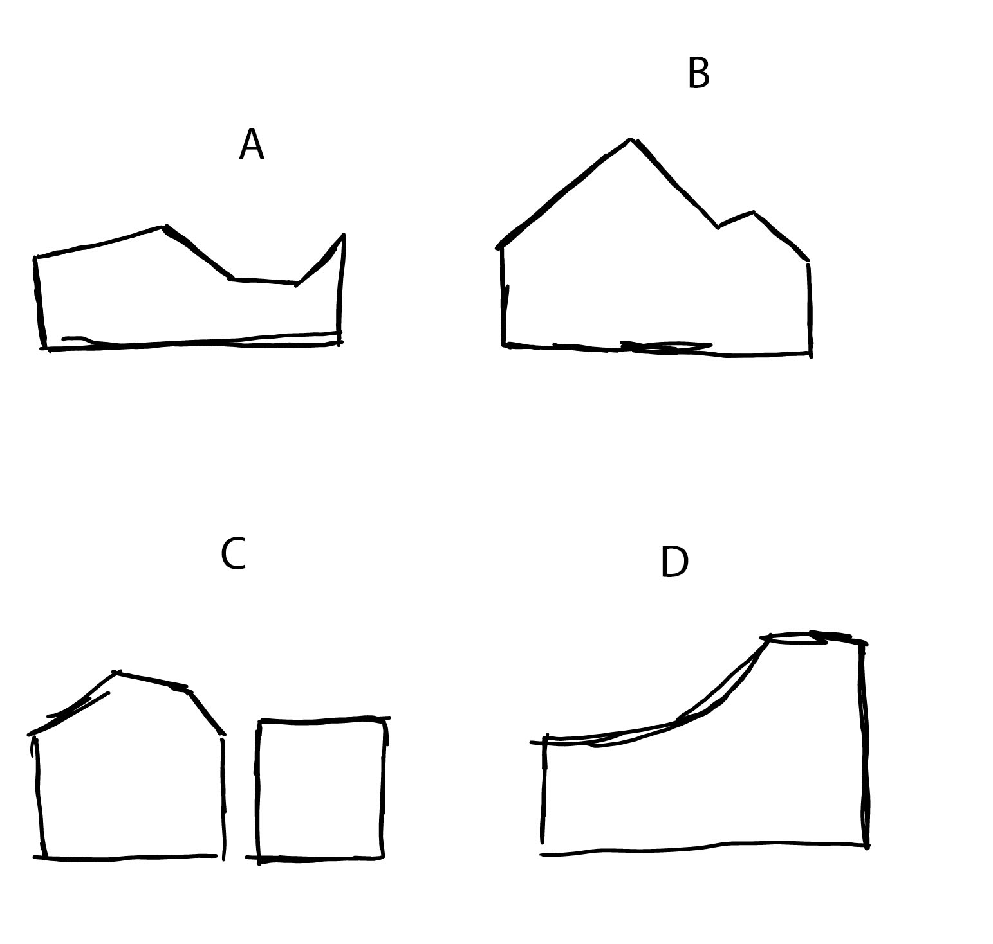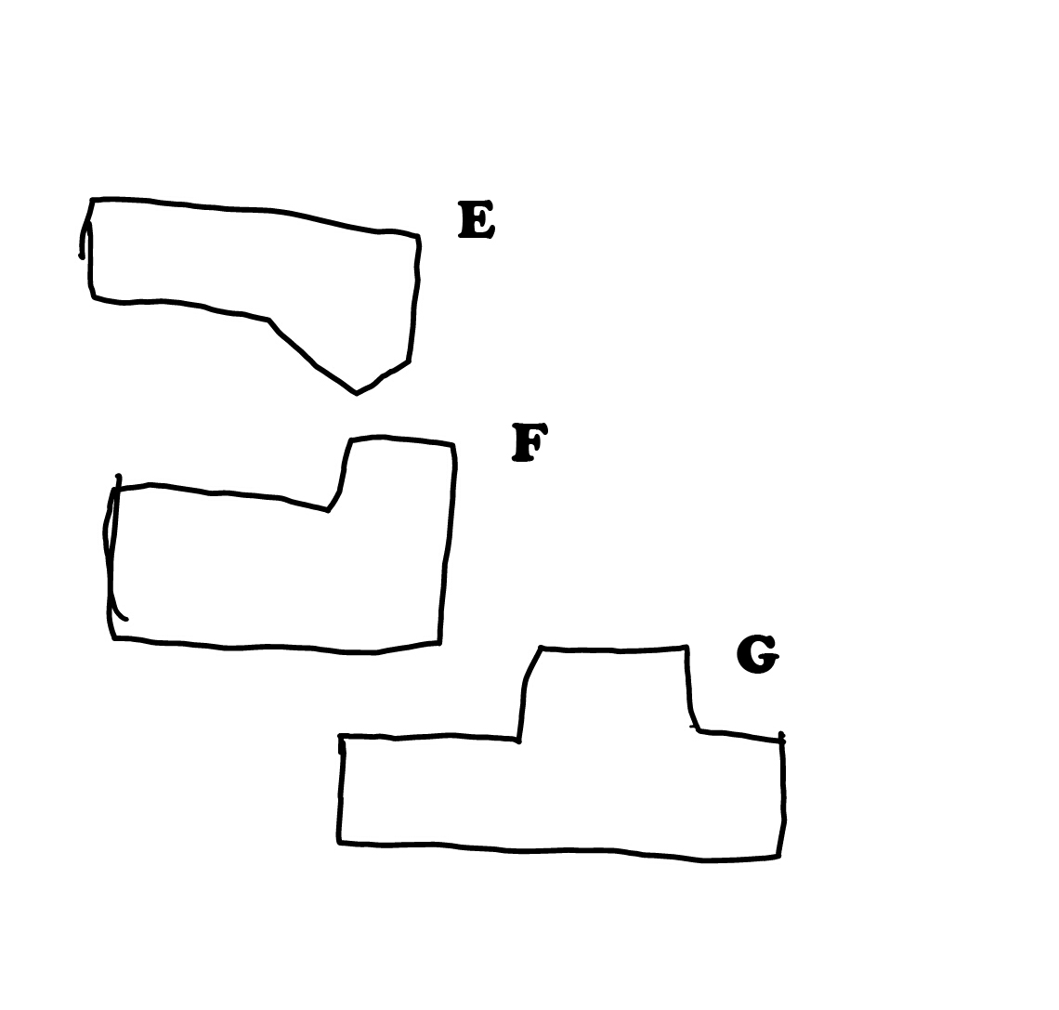

Sound and Music

Sound Effects

